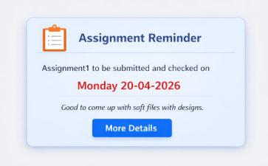

QUESTION 1
A supermarket in Kigali wants to develop a small JavaScript program to help calculate the total cost of items purchased by a customer. The cashier enters the price of an item and the quantity purchased, and the system should automatically calculate the total amount to be paid. In addition, the supermarket has introduced a discount policy. If the total amount is greater than 50,000 RWF, the customer receives a 10% discount. Otherwise, no discount is applied.
Using JavaScript, develop a script that performs the following tasks:
Tasks
- Write a script that prompts the user to enter the price of an item and the quantity purchased
- Calculate the total cost of the items using JavaScript
- Use conditional statements to check whether the customer qualifies for the 10% discount
- Display the final amount to be paid using alert() or document. write()

QUESTION 2
- Create a basic HTML structure with a <div> container where a Weather Summary Card will be displayed.
- Using JavaScript DOM manipulation and the querySelector () method, create and insert elements for the heading “Today’s Weather”, a number representing the temperature (e.g., 28°C), a short description such as “Sunny with light breeze”, and a button labeled “More Details”.
- Apply CSS styles using JavaScript to make the card visually appealing. The styling should include background color, text formatting, spacing, border radius, shadow effects, and button styling with hover effects.
- Add an event listener to the “More Details” button so that when it is clicked, it displays an alert message saying “Loading detailed forecast...”.
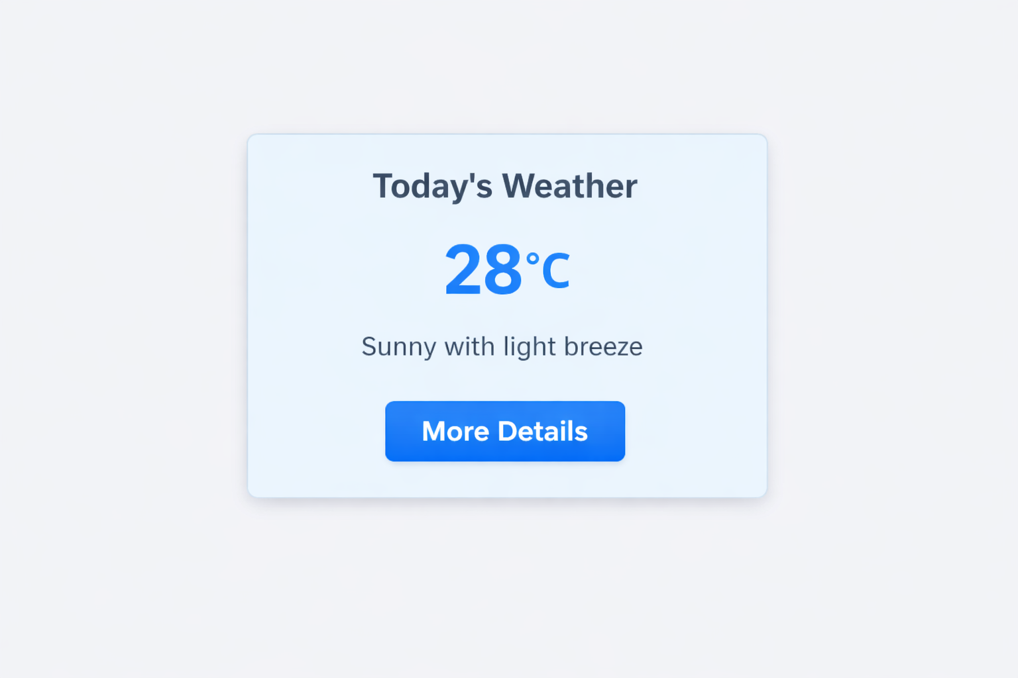

QUESTION 3
You are part of the development team for the “My Food Recipe” web application. The application displays various food items organized by category. The administrator wants a feature where users can click a category (e.g., “Lunch”) and a modal popup appears, displaying all recipes in that category. Each recipe should show an image, recipe name, and category, as in the screenshot provided. The modal should also have a “Close” button to hide it.
TASKS
- Create an HTML structure that displays a modal containing five lunch recipes with images, names, and categories as shown in the screenshot. Include a “Close” button in the modal. And enhance the modal with CSS styling so that each recipe card has a border, some padding, and the recipe names are bold.
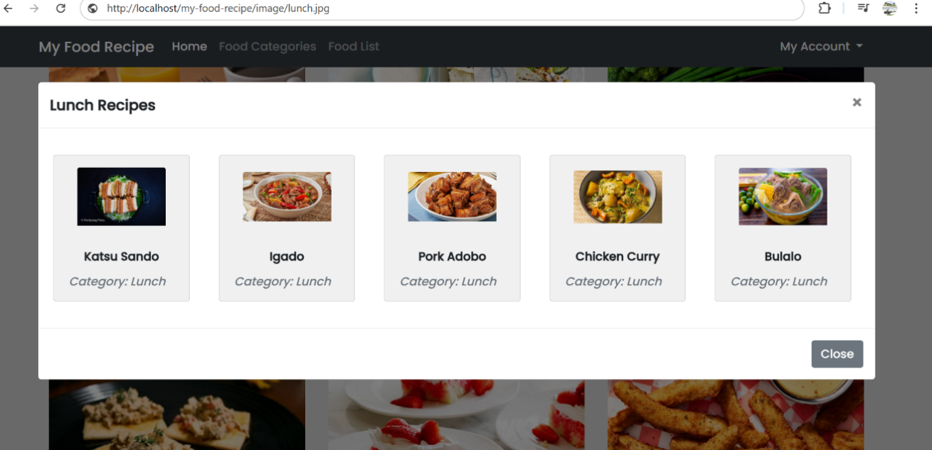
- Write JavaScript code that allows the modal to be displayed when a “Lunch” category button is clicked and hidden when the “Close” button is clicked.

END

